University of Petroleum and Energy Studies
School of Computer Science
Department of Cybernetics

Graphics & Animation Tools
LAB FILE
(Session: 2020-2021)

Course: B.Tech with Specialization in Open Source and Open Standards

Submitted To- Submitted By-
Dr. Durgansh Sharma Rahul Raj Baranwal
Associate Professor SAP ID -500061624
Department of Cybernetics Roll No. -R100217054

Experiment-5 Design of 3D Text using Blender.
In this experiment we need to create a 3D Text of our choice with the help of blender.
Steps to follow to create a 3D design using Blender
- Open Blender, and clear everything from the interface which are already there.
- Create a new file and go to mesh, click on text and edit it using TAB key and write whatever you want to write.
- Go to the alignment and make the text at the centre. Go to geometry and extrude the text a little bit. Also, bevel at least 0.001 for the lights to catch the curve of your text.
- We want the lights to going around the text and hitting the edges of text, so add camera at the centre. To make the lights going around the text add a circle at the centre of the text.
- Add light, and go to constraint and add follow path (Circle). Now, hit the tab button and resize the circle as close to the path, so that they are very close to the text.
- We want this as animation, so add frame rate (120fps). Change the render engine to eevee.
- Now go to world and add black as background. And add metallic texture as well. Add bloom and screen space reflection.
- Now add blue colour in the text and also make its strength 100.
- Now save the blender project at your preferable location and also render the files.

Output Screen:
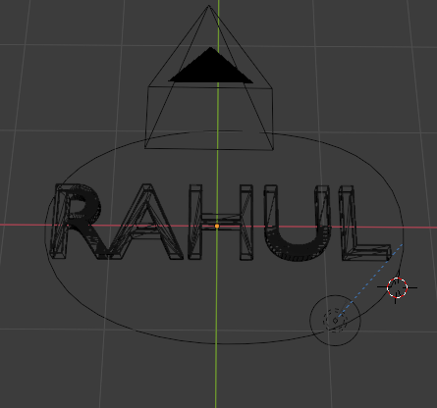

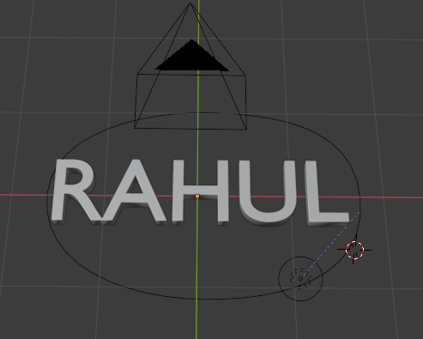

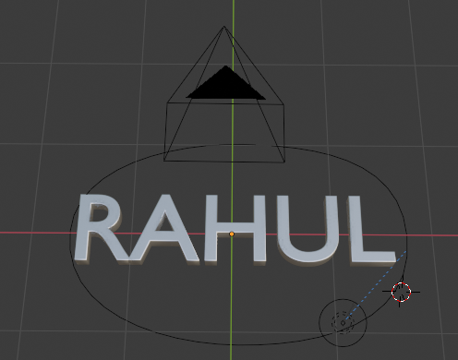

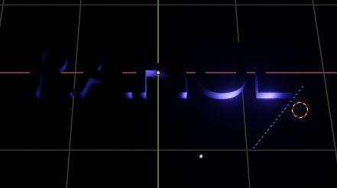

Link for the experiments:

